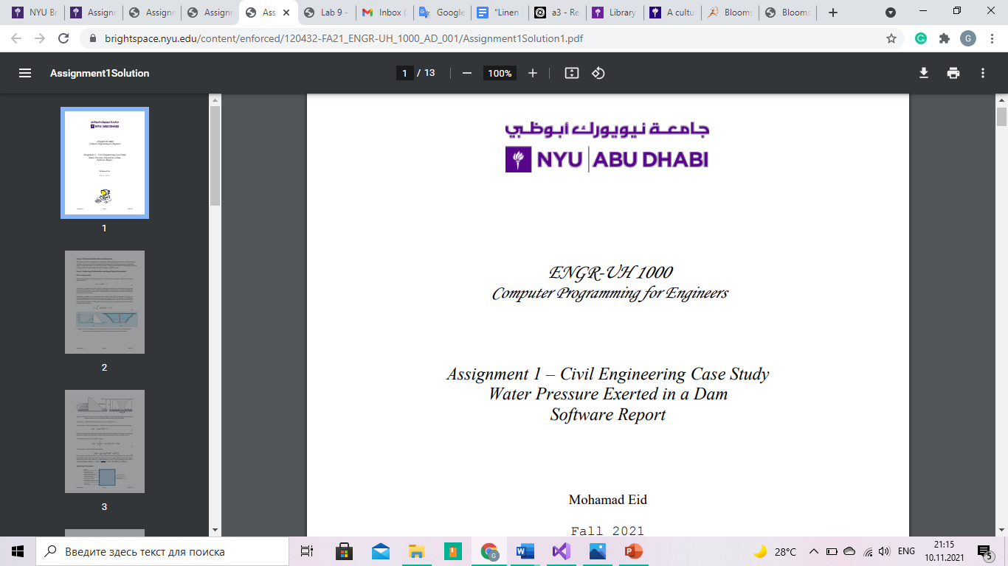

ENGR-UH 1000
Computer Programming for Engineers

Assignment 3 – Computer Engineering Case Study Concordance of a Text File Software Report

Gulsim Azirakhmet
Fall 2021

Step 1: Problem Identification and Statement
The objective of this assignment is to develop a program that processes a text file and produces a concordance: an alphabetical listing of the words in the file and the number of times each word appears (frequency).
Step 2: Gathering of Information and Input/Output Description
A task often performed in information retrieval is the determination of the "most important concepts" of a text document. The result gained from this program may be used to do a Web search – a search engine analyzes Web pages to determine whether their content agrees with the search criteria. Moreover, program helps to identify key words in the text, making it useful for defining the topic and main idea of the text.
A concordance of a text file is an alphabetical list of the unique words in the text file. Here is a concordance of the preceding sentence, sorted alphabetically, along with the frequency of occurrence for every word:
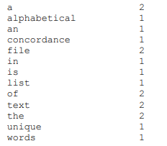
It is useful to track the number of times each unique word appears in the text file to identify the most important concepts in the file.
As a first step in intelligent information retrieval, a program that processes a text file and produces a concordance: an alphabetical listing of the words in the file and the number of times each word appears (frequency) should be developed. Punctuation and other non-alphabetic symbols (including numbers) should be ignored. The concordance (list of unique words along with their frequency of occurrence in the file) must be stored to an output file and displayed on the output screen.
In order to tokenize the string into multiple words, it will be useful to save each word in dynamic array when there is a whitespace. The size of the dynamic array will be identififed by reading the text from the file and counting the number of words.
By using 2 dimensional dynamic array and checking each character in the text the non-alphabetical characters may be eliminated. By comparing the ASCII numbers of the words the alphabetical order of words can be created. Also, by comparing words and counting their occurrence the frequency of occurrence of each word can be calculated.

Input/Output description:
Filename from the user, for file
Confirmation message
to write the concordance list
filename2.txt
Filename from the user, for the
file to read the text
concordance list
filename.txt
Step 3: Design of the algorithm and hand-solved problems
Test cases:
Test Case 1: Conversion of upper case letters to lower case
Text in the file:
“Hi hi! My name is Gigi!
Just just just che!cking my m1y program1
I hope it works though
Hello_World”
On the output screen and file named “filename2.txt”:
Data is stored in the file.
checking | 1
gigi | 1
helloworld | 1
hi | 2
hope | 1
i | 1
is | 1
it | 1
just | 3
my | 3
name | 1
program | 1
though | 1
works | 1
The program converts upper case letters to lower case letters. Thus, program counts the occurrence of the words correctly. Intstead of counting the occurrence of the word with upper case letter seperately from the same word with lower case letter, program converts all words to the lower case letter first then counts their occurrence.
Test Case 2: Ignorance of punctuation characters
Text in the file:
“Hi hi! My name is Gigi!
Just just just che!cking my m1y program1
I hope it works though
Hello_World”
On the output screen and file named “filename2.txt”:
Data is stored in the file.
checking | 1
gigi | 1
helloworld | 1
hi | 2
hope | 1
i | 1
is | 1
it | 1
just | 3
my | 3
name | 1
program | 1
though | 1
works | 1
The program ignores the exclamation points. Thus, program does not count them as a word and does not display the frequency of their occurrence.
Test Case 3: Alphabetical listing of the words
Text in the file:
“Hi hi! My name is Gigi!
Just just just che!cking my m1y program1
I hope it works though
Hello_World”
On the output screen and file named “filename2.txt”:
Data is stored in the file.
checking | 1
gigi | 1
helloworld | 1
hi | 2
hope | 1
i | 1
is | 1
it | 1
just | 3
my | 3
name | 1
program | 1
though | 1
works | 1
The program orders words in the alphabetical order, which makes it easier for the user to find the word.
Test Case 4: Frequency of the words
Text in the file: “Hi hi! My name is Gigi!
Just just just che!cking my m1y program1
I hope it works though
Hello_World”
On the output screen and file named “filename2.txt”:
Data is stored in the file.
checking | 1
gigi | 1
helloworld | 1
hi | 2
hope | 1
i | 1
is | 1
it | 1
just | 3
my | 3
name | 1
program | 1
though | 1
works | 1
The program orders words in the alphabetical order, which makes it easier for the user to find the word. It also shows the frequency of occurrence of each word in the text.
Algorithm design:
Declare function ReadFile(filename, NumberofWords)
Declare function ReadfromFile(filename, NumberofWords, arrayofwords)
Declare function ReadText(NumberofWords, arrayofwords)
Declare function AlphabeticalOrder(NumberofWords, words)
Declare function FrequencyofOccurence(wordRead, words, NumberofWords, wordCount)
Declare function WriteToFile(wordRead, wordCount, NumberofWords, words, filename1)
main() function
declare filename, filename1, wordRead as string
declare wordCount=1, NumberofWords = 0 as integer
assign function ReadFile to NumberofWords
declare arrayofwords as dynamic array with new size NumberofWords
assign function ReadfromFile to array of words
assign function ReadText to array of words
assign function AlphabeticalOrder to array of words
assign function FrequencyofOccurence to array of words
call function WriteToFile
delete dynamic array arrayofwords

function ReadFile
declare wordRead as string
print “Please, enter the name of the file”, newline
read into filename
open filename text file for reading to count the number of words
if wordNumber fails to open
print “Failed to open file”
while text reaches the end
increment numberofwords
read wordRead from wordNumber
close the wordNumber file
return NumberofWords to the main function

fucntion ReadfromFile
open filename text file for reading to count the number of words
if wordNumber fails to open
print “Failed to open file”
for i=0 to i<NumberofWords do
read array arrayofwords from SaveToArray
increment i
close the wordNumber file
return arrayofwords to the main function

function ReadText
for row=0 to row < NumberofWords do
for column=0 to 2 dimensional array arrayofwords with row numbers of row and column numbers of column not equal to delimiter do
if (2 dimensional array arrayofwords with row numbers of row and column numbers of column)< 'A' or ((2 dimensional array arrayofwords with row numbers of row and column numbers of column)> 'Z' and (2 dimensional array arrayofwords with row numbers of row and column numbers of column)< 'a') or (2 dimensional array arrayofwords with row numbers of row and column numbers of column)> 'z'
assign lower case 2 dimensional array with row numbers of row and column numbers of column to 2 dimensional array arrayofwords with row numbers of row and column numbers of column
increment column

for column=0 to 2 dimensional array arrayofwords with row numbers of row and column numbers of column not equal to delimiter do
if (2 dimensional array arrayofwords with row numbers of row and column numbers of column)< 'A' || ((2 dimensional array arrayofwords with row numbers of row and column numbers of column)> 'Z' && (2 dimensional array arrayofwords with row numbers of row and column numbers of column)< 'a') || (2 dimensional array arrayofwords with row numbers of row and column numbers of column)> 'z'
assign delimeter to 2 dimensional array arrayofwords with row numbers of row and column numbers of column
increment column
remove delimeters from the array arrayofwords with size row
increment row
return arrayofwords to the main function

function AlphabeticalOrder
declare temp as string
for row=0 to row<NumberofWords do
for j=row+1 to j<NumberofWords do
if array words with size row> array words with size j
assign array words with size row to temp
assign array words with size j to array words with size row
assign temp to array words with size j
increment j
increment row
return words to main function

function FrequencyofOccurence
assign first element of array words to wordRead
output messages assigned to the left
for m=1 to m<NumberofWords do
if wordsRead not equal to array words with element m
print assign 20 cells from the left, wordRead, 20 cells, wordCount, newline
assign 0 to wordCount
assign array words with element m to wordRead
increment wordCount
increment m
print assign 20 cells from the left, wordRead, 20 cells, wordCount, newline
return words to main function

function WriteToFile
print “Please, enter the name of the file”, newline
read into filename1
open filename1 text file for writing
if concordance fails to open
print “Failed to open file”
assign first element of array words to wordRead
for m=1 to m<NumberofWords do
if wordsRead not equal to array words with element m
write assign 20 cells from the left, wordRead, 20 cells, wordCount, newline into concordance
assign 0 to wordCount
assign array words with element m to wordRead
increment wordCount
increment m
write assign 20 cells from the left, wordRead, 20 cells, wordCount, newline into concordance
print “The concordance of the words is saved in text file.”, newline

Step 4: Implementation
///////////////////////////////////////////////
// Description: Computer Engineering Case Study
// A C++ Program to make the concordance of the words from the given text
// Author: Gulsim Azirakhmet
// Date Created: November 1, 2021
// NYUAD Assignment 3
///////////////////////////////////////////////

//Headers
#include <iostream>
#include <fstream>
#include <iomanip>
#include <string>
#include<algorithm>
#include<cctype>

//Namespaces
using namespace std;

int ReadFile(string& filename, int& NumberofWords);//opens the file and reads number of words and strings in the file
string* ReadfromFile(string filename, int NumberofWords, string* arrayofwords);//opens the file and reads strings into arrayofwords dynamic array
string* ReadText(int NumberofWords, string* arrayofwords);//function to sort the words from punctuation characters and turn them to lower case
string* AlphabeticalOrder(int NumberofWords, string* words);//function to sort the words in alphabetical order
string* FrequencyofOccurence(string wordRead, string* words, int NumberofWords, int wordCount);//function to count the frequence of occurence of each word
void WriteToFile(string wordRead, int wordCount, int NumberofWords, string* words, string& filename1);//function to write the concordance to a file

//Main Function (Entry Point)
int main() {
string filename, filename1, wordRead;//declare filename, filename1, wordRead as string
int wordCount = 1, NumberofWords = 0;//declare wordCount = 1, NumberofWords = 0 as integer

NumberofWords = ReadFile(filename, NumberofWords);//assign function ReadFile to NumberofWords
string* arrayofwords;//declare dynamic array
arrayofwords = new string[NumberofWords];//give new size to the dynamic array
arrayofwords = ReadfromFile(filename, NumberofWords, arrayofwords);//assign function ReadfromFile to array of words
arrayofwords = ReadText(NumberofWords, arrayofwords);//assign function ReadText to array of words
arrayofwords = AlphabeticalOrder(NumberofWords, arrayofwords);//assign function AlphabeticalOrder to array of words
arrayofwords = FrequencyofOccurence(wordRead, arrayofwords, NumberofWords, wordCount);//assign function FrequencyofOccurence to array of words
WriteToFile(wordRead, wordCount, NumberofWords, arrayofwords, filename1);//function to write the concordance to a file

delete[] arrayofwords;//deletes dynamically allocated array arrayofwords
return 0;//default return code(0) for normal exit
}

int ReadFile(string& filename, int& NumberofWords)//opens the file and reads number of words and strings in the file
{
string wordRead;//declare wordRead as string
cout << "Please, enter the name of the file" << endl;//prints message to the output screen
cin >> filename;//reads input to the filename

ifstream wordNumber;
wordNumber.open(filename, ios::in);// open file to count the number of words
if (wordNumber.fail())//if file fails to open
{
cerr << "Failed to open file";//print the message
exit(-1);//return (-1) if file fails to open
}

while (!wordNumber.eof())//until the end of the file
{
wordNumber >> wordRead;//reads words from the file to wordRead
NumberofWords++;//counts number of words inside the file
}
wordNumber.close();//close the wordNumber file

return NumberofWords;//return NumberofWords to the main function

}

string* ReadfromFile(string filename, int NumberofWords, string* arrayofwords)//opens the file and reads strings into arrayofwords dynamic array
{
ifstream wordNumber;
wordNumber.open(filename, ios::in);// open file to store words into string array
if (wordNumber.fail())//if file fails to open
{
cerr << "Failed to open file";//print the message
exit(-1);//return (-1) if file fails to open
}

for (int i = 0; i < NumberofWords; i++)//loop to continue action NumberofWords times
{
wordNumber >> arrayofwords[i]; // stores the text into the array
}
wordNumber.close();//close wordNumber file
return arrayofwords;// return arrayofwords to the main function
}

string* ReadText(int NumberofWords, string* arrayofwords)//function to sort the words from punctuation characters and turn them to lower case
{

for (int row = 0; row < NumberofWords; row++)//loop to continue action NumberofWords times
{
for (int column = 0; arrayofwords[row][column] != '\0'; column++)//loop to continue action until the character equals to delimeter
{
if ((arrayofwords[row][column] >= 'a' && arrayofwords[row][column] <= 'z') || (arrayofwords[row][column] >= 'A' && arrayofwords[row][column] <= 'Z'))//if character is alphabet
{
arrayofwords[row][column] = (char)tolower(arrayofwords[row][column]);//change characters to lower case characters
}

if (arrayofwords[row][column] < 'A' || (arrayofwords[row][column] > 'Z' && arrayofwords[row][column] < 'a') || arrayofwords[row][column] > 'z')//if character is symbol
{
arrayofwords[row][column] = '\0';//character equals to delimeter
}
}

arrayofwords[row].erase(remove(arrayofwords[row].begin(), arrayofwords[row].end(), '\0'), arrayofwords[row].end());//remove delimeters from the text

}
return arrayofwords;//return arrayofwords to the main function
}

string* AlphabeticalOrder(int NumberofWords, string* words)//function to sort the words in alphabetical order
{
string temp;//declare temp as string

for (int row = 0; row < NumberofWords; ++row)//loop to continue action for NumberofWords times
{
for (int j = row+1; j < NumberofWords; ++j)//loop to continue action from row+1 till the NumberofWords
{
if (words[row] > words[j])//if ASCII number of word in the text is larger than the ASCII number of the next word in the text
{
temp = words[row];//assign word to the temp
words[row] = words[j];//assign next word to the array words[row]
words[j] = temp;//assign word to the array words[j]
}
}
}
return words;//return words to main function
}

string* FrequencyofOccurence(string wordRead, string* words, int NumberofWords, int wordCount)//function to count the frequence of occurence of each word
{
wordRead = words[0];//assign first word in the array to the wordRead
cout.setf(ios::left);//output messages assigned to the left

for (int m = 1; m < NumberofWords; m++)//loop to continue NumberofWords times
{
if (wordRead != words[m])//if other words is not equal to the first word
{
cout << setw(20) << wordRead << setw(20) << wordCount << endl;//print the word with the wordCount=1
wordCount = 0;//assign 0 to wordCount
wordRead = words[m];//assign words[m] to wordRead
}
wordCount++;//otherwise increment wordCount
}
cout << setw(20) << wordRead << setw(20) << wordCount << endl;//print the word with the wordCount
return words;//return words to main function
}

void WriteToFile(string wordRead, int wordCount, int NumberofWords, string* words, string& filename1)//function to write the concordance to a file
{
cout << "Please, enter the name of the file to store the data" << endl;//prints message to the output screen
cin >> filename1;//reads input to the filename1

ofstream concordance(filename1, ios::out);//opens file concordance for writing
concordance.setf(ios::left);
if (concordance.fail()) // if file fails to open
{
cerr << "Failed to open file";//print the message
exit(-1);//return (-1) if file fails to open
}

wordRead = words[0];//assign first word in the array to the wordRead
for (int m = 1; m < NumberofWords; m++)//loop to continue NumberofWords times
{
if (wordRead != words[m]) // if other words is not equal to the first word
{
concordance << setw(20) << wordRead << setw(20) << wordCount << endl;//write the word with the wordCount=1 into concordance file
wordCount = 0;//assign 0 to wordCount
wordRead = words[m];//assign words[m] to wordRead
}
wordCount++;//increment wordCount
}
concordance << setw(20) << wordRead << setw(20) << wordCount << endl;//write the word with the wordCoun into concordance file
cout << "The concordance of the words is saved in text file. " << endl;//print message on the output screen
}
Step 5: Software Testing and Verification
Test Case 1: Conversion of upper case letters to lower case
Input:
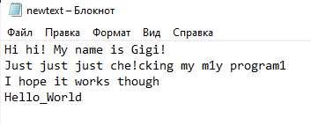
Output:
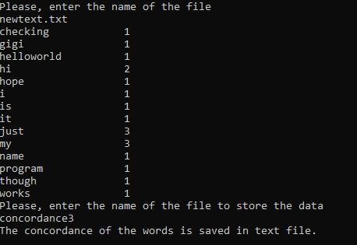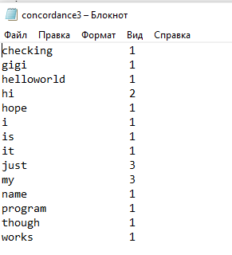
All the words are converted to lower case.

Test Case 2: Ignorance of punctuation characters
Input:
Output:
All the characters except alphabets are ignored. Characters which are in the middle of the word are removed.

Test Case 3: Alphabetical listing of the words
Input:
Output:
All the words are listed in the alphabetical order.

Test Case 4: Frequency of the words
Input:
Output:
The frequency of occurrence of the words is counted and shown near the word.

User’s Guide
This program will help you to identify the frequency of occurrence of each word in your text. Thus, keywords in the text may be identified. You may enter the name of the file, whereyour text is stored. The program will give you concordance in the output screen. You may also enter the name of the text file to store the final result.

